Double Up Food Bucks Colorado 2023 Evaluation

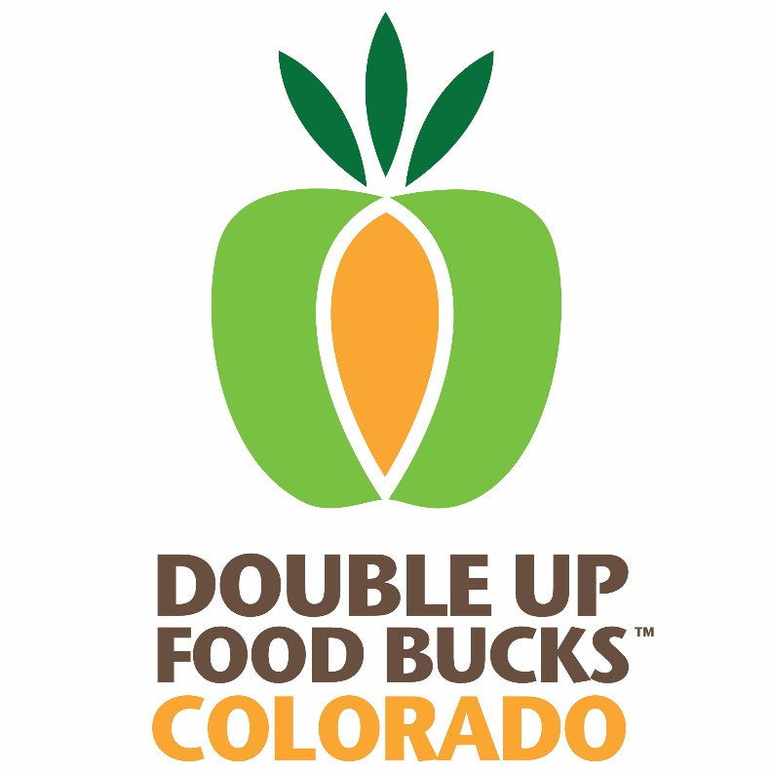

Contents
I. Introduction 3
II. Customer Interaction with Double Up 3
Financial Impact 3
Customer Visits 4
Customer Experience 5
Preliminary 2023 Findings 5
III. Customer Demographic Trends 5
IV. Customer Attitudes and Behaviors 5
Customer Attitudes toward Double Up 5
Changes in Behavior from Double Up 6
V. Findings & Conclusion 6
VI. References 6

For more information on 2023 Double Up evaluation results, please refer to the other focused evaluation reports and Appendix A for all tables and figures referenced in this report.
- Full Report (this document)
- Appendix A: Tables and Figures

Impact on SNAP Recipients

Introduction
One of the primary goals of Nourish Colorado’s Double Up Food Bucks (Double Up) Program is to increase the fruit and vegetable consumption of Supplemental Nutrition Assistance Program (SNAP) recipients in Colorado. The program matches up to $20 of SNAP recipients’ purchases of Colorado-grown fresh fruits and vegetables, every time they visit a participating Double Up location. This report provides a summary of Double Up customers’ participation in the program and will take a deeper look at the feedback collected from participants on perceptions and attitudes about the program and its impact on consumption patterns over time.
In order to evaluate the impact on SNAP recipients, the 2023 evaluation program used the following methods and tools (Table 1: Evaluation Tools to Measure Program Reach and Impact):
- Vendor Reports – tracked Double Up and SNAP incentives spent by customers at Double Up sites
- Customer Surveys – administered to customers online via Qualtrics; collected information on DUFB participation history, consumption of various food groups, health, and demographics; collected 380 surveys in 2023
- Analysis of Strategies – analysis of specific strategies by market type, county, or region; analyzed data collected by other tools

Customer Interaction with Double Up

Financial Impact
The Double Up program resulted in an additional $2,529,907 being spent in 2023 on Colorado-grown fruits and vegetables by SNAP recipients (Table 2: Incentives Redeemed (Spent) by Year). Table 2 in Appendix A presents the SNAP, Double Up, and total incentives redeemed by customers, according to vendor reports. In 2023, $1,601,625 in SNAP vouchers were distributed to participants, an 81% increase from 2021, and $1,201,520 in DUFB vouchers were distributed, a 59% increase from 2021 (Table 3: Incentives Distributed by Year).
The Double Up program continues to expand every year, which is especially notable in 2023 due to the decrease in SNAP distributions that occurred after the COVID pandemic ended. For example, in Colorado, Pandemic-EBT benefits ceased in mid-July of 2023. Interestingly, SNAP Distributions (and redemptions) at vendors participating in the Double Up program peaked in September and October of 2023 (Figure 1). This may have been due to a rollover effect; since SNAP benefits rollover to the next month, it is possible that SNAP some SNAP participants had accumulated benefits and wanted to spend them before the end of the market season. On the other hand, distribution and redemption of Double Up Bucks peaked in July-September (Figure 2). The discrepancy between the peaks of Double Up and SNAP may be attributed to product availability, as fewer fresh fruits and vegetables are available at farmers markets in October compared to July.
Most often, customers receive their vouchers at a farmers market booth and then redeem the vouchers with a vendor that sells Colorado-grown fresh fruits and vegetables. In 2023, customers redeemed $885,022 in Double Up incentives, an increase of 83% from 2022, and $1,674,885 in SNAP incentives, an increase of 89% from 2021 (Table 2: Incentives Redeemed (Spent) by Year). The amount of Double Up Bucks redeemed is the dollar value of what customers actually spent on local fruits and vegetables at the Double Up site. The difference between distributed and redeemed Double Up vouchers is the value of vouchers redeemed, but never spent by customers. The percent of Double Up vouchers distributed but never redeemed decreased from 2021; around 71% of Double Up Bucks were redeemed, which is up from 61.7% in 2021 (Table 11: Percent of Distributed Incentives Redeemed Each Year). This is an encouraging reversal of a pattern; the percent of redeemed double up bucks had decreased every year since 2017, but increased from 2021 to 2023.
The decrease in the percent of Double Up vouchers distributed but not redeemed might again be explained by the decrease in emergency food assistance funds that occurred since the end of the pandemic. A decrease in food spending money might imply that SNAP participants are more dependent on the extra assistance that Double Up Bucks yield. Further, the growth in Double Up sites, from 81 in 2021 to 115 in 2023, might have increased accessibility to markets for some SNAP recipients that could not previously get to sites. The new audiences that are reached by this expansion may have had more limited access to fresh fruits and vegetables before the launching of the Double Up program at their preferred site.
In 2020, Nourish/GUSNIP developed a new partnership with Save-A-Lot retail stores, who then participated in the Double Up program. Since then, this has led to a larger proportion of Double Up Bucks being distributed and redeemed at Brick and Mortar stores compared to “Farm Direct” outlets. In 2023, 79% of Double Up Bucks were distributed at Brick and Mortar outlets, which is substantially larger than the 21% of Double Up Bucks that were distributed at Farm Direct outlets. Figure 5 shows the monthly breakdown of redeemed Double Up Bucks by firm type. It is clear that in the months when farmers markets are not running, almost all of the redeemed Double Up Bucks occur at Brick and Mortar stores. On the other hand, the redemption of Double Up Bucks is more balanced during the summer months (Figure 5). These results also imply that the addition of Brick and Mortar stores to the Double Up program has substantially increased the affordability of fresh fruits and vegetables during months when farm-direct availability might be lacking.

Customer Visits
Not all vendors were able to track the number of SNAP transactions and most were not able to track unique customers, but from the data available, there were 42,784 reported SNAP transactions and 4,120 unique customers in 2023. Due to the missing data, participation in the Double Up program is best measured by the previously discussed distribution and redemption data.
Customer Experience
The Double Up team used convenience sampling to survey customers at Double Up venues to learn more about customers’ experience at the market. For 2023, surveys were collected online via Qualtrics. Three hundred and eighty (380) customers completed a customer survey in 2023. Of those surveyed in 2023, 21% had been enrolled in SNAP for a year or less at the time of survey, and 12% reported just getting started with SNAP. 64% reported using SNAP for more than a year, and 3% did not know or preferred not to answer the question (Table 6: Customer Use and Experience). The consistent percentage of new customers to the program each year can be attributed to the nature of the SNAP program. SNAP recipients are required to regularly recertify for the program to confirm eligibility (within a range of one month to two years). The recertification cycles mean the population of SNAP recipients is constantly changing and households may go on and off the program as their eligibility changes.
About 26% of customers were surveyed during their first Double Up experience of the year, which is slightly less than previous years (down from 40% in 2019, but up from 21% in 2021). 35% of customers were surveyed in the first year of their Double Up usage, while 17% had been using Double Up for 1-2 years and 16% had been using the program for 2-5 years. Only 3% of respondents had been using the program for more than 5 years (Table 6: Customer Use and Experience).

Customer Demographic Trends
The customer surveys conducted at the Double Up venues collected information on the demographics of Double Up Customers. The evaluation compares this information to previous Double Up years to look for trends, but the other primary purpose is to compare demographics of Double Up customers to the demographics of the wider SNAP population in Colorado. Understanding how demographics align may be used to assess whether Double Up is under-serving certain populations. If that is the case, Nourish can adjust customer outreach strategies accordingly (see Community Partnerships report for more details). However, there is no way to know whether this survey sample is truly representative of the population that uses the Double Up program.
2023 Demographic Trends (Table 5: Customer Demographics)
- 380 customers responded to the customer survey in 2023.
- Women continued to be the majority of participants at 68% of all surveyed respondents in 2023.
  - There was a decrease in male respondents from 2021 to 2023 (32% to 23%).
  - In Colorado, adult females outnumber males living in poverty in every age range, with females 18 to 25 years of age making up the largest share living in poverty at about 10% (Deloitte, 2017).
  - Nationally, approximately 57% of SNAP participants are female and 43% are male; this is a breakdown of all household members, including children (U.S. Department of Agriculture, Food and Nutrition Service, Office of Policy Support, 2017).
  - In addition, women are more likely to take on primary responsibility for household chores like grocery shopping, so they may constitute a higher proportion of the Double Up population for that reason as well (Flagg et al., 2013).
- As in previous years, most respondents identified as White (71%) and 65 respondents (17%) identified as Hispanic or Latino/a
  - At 3%, the percentage of respondents identifying as American Indian or Alaskan Native decreased from 2021 (4%). This figure is still above the 1% of individuals living in poverty in Colorado who identify as Native American.
  - Based on data from the U.S. Census Bureau, of all individuals living in poverty in Colorado, 56% identified as White and 26% identified as Hispanic, with all other demographics falling slightly below 10% (Deloitte, 2017). The observation that this sample has a higher percentage of white respondents compared to the population that is likely to be eligible for SNAP may be a result of the survey recruitment process, or may also point to issues that minority populations may experience when considering enrollment in food assistance.
- 55% of respondents were identified as food insecure at the time of survey, which is a 2% decrease from 2021.
  - Food insecurity levels were calculated from the first question in the USDA food security measure, which is consistent with previous literature (USDA, 2012). A household was classified as food insecure if they reported sometimes or often experiencing that “the food they bought didn’t last, and they didn’t have money to get more.”
  - 40% of the sample were classified as food secure, and 5% did not know and/or preferred not to answer.
- A majority of respondents have received SNAP benefits for more than one year, at 64% of all surveyed respondents in 2023.
  - Just 12% of respondents started using benefits within the month and 21%. have used SNAP benefits for less than a year. This turnover is consistent with SNAP turnover rates.
- While 88% of participants utilize farmers markets for DUFB transactions, 23% also use grocery stores for DUFB benefits. These proportions decreased from 2021, reflecting an increase in the diversity of options that are available for usage of Double Up Food Bucks.
  - This might also be a result of the continued growth in grocery store partnerships with DUFB, including the partnership with Save A Lot stores.

Customer Attitudes and Consumption Behaviors
The evaluation approach primarily used customer surveys to learn about the impact of the program on customers. Survey participants were asked about their attitudes toward the program and various consumptions patterns.

Customer Attitudes toward Double Up
An important goal of the Double Up program is to increase access to high-quality food choices to support healthy eating behaviors. For this reason, the evaluation program asks survey respondents to rate their experience using Double Up sites. 91% of respondents indicated that their experience was either ‘positive’ or ‘very positive’. 5% of respondents indicated their experience was ‘neutral’, 3% indicated that they didn’t know and/or preferred not to answer, and only 1 respondent recorded a negative or very negative experience (Table 7: Average Ratings of Market Experience by Demographic). We further broke down market experience by demographic so that we might use this information to identify what populations we might need to target for constructive feedback on the program.
Market Experience by Demographic (Table 7: Average Rating of Market Experience by Demographic)
- Of the 20 respondents that indicated their market experience was neutral, 12 were white, 1 was Black or African American, 1 was Asian, and 6 were Mixed race.
  - 4 of those respondents identified as Hispanic or Latino/a
- The spread of neutral responses across gender was fairly even
- The portion of respondents reporting positive and very positive experiences were proportional to the representation of races and ethnicities.
- We also observed customer attitudes across food security classification.
  - Experience was again mostly proportional to the sample’s representation, but food insecure respondents reported neutral experiences at slightly higher rates.

Consumption Behavior during Double Up use
Surveyed customers were also asked to report the frequency of specific food consumption patterns. Understanding behavior around fruit and vegetable consumption is a primary goal of the evaluation program. While we cannot empirically estimate behavior changes because we do not have access to pre and post consumption data, pre-program purchasing data, nor data from a control group without access to the program, we can still evaluate customers’ perception of their own consumption behavior.
According to 2023 customer survey data:
- 65% of customers indicated that they eat vegetables 3 or more times per week
- 62% of customers reported eating salad 3 or more times per week
- 66% of customers reported eating fruit 3 or more times per week.
- 26% of customers reported eating beans 3 or more times per week
- Only 4% of surveyed customers drink fruit juice daily and 26% of customers indicated they never drink fruit juice. 18% reported drinking fruit juice 3 or more times per week.
- Only 17% of respondents reported eating fried potatoes 3 or more times per week.
- 22% of respondents reported eating pizza 3 or more times per week.
(Figure 3: Customers’ Healthy Food Consumption; Figure 4: Customers’ Fried Food and SSB Consumption show more details).

Conclusions and Recommendations
In 2023, the Double Up program again continued to grow in Colorado. Both the number of Double Up sites and the total redeemed Double Up dollars increased substantially relative to 2021. Since P-EBT ended in the Summer of 2023 in Colorado, we may not have seen the total impact of pandemic-era assistance ending in these data. However, the increased number of vendors participating in the Double Up program and continued year-over-year growth are positive indicators for the performance of the Double Up program. When comparing Double Up redemption at brick and mortar stores to farm direct outlets, it is evident that brick and mortar stores are driving much of the expansion in the Double Up program, and fulfill a much-needed purpose of increasing affordability of fresh fruits and vegetables during the off-season of farmers markets. A future point of analysis might be to conduct the customer survey at two points of time during the year; once during the summer and once during the winter, for example. This would highlight the consumption behavior differences in Double Up customers’ who utilize brick and mortar stores vs. farmers markets.
While it is clear that the Double Up program is working to increase food and nutrition security, the majority of the survey sample continued to report experiencing food insecurity. One factor that Nourish/GUSNIP might consider is the “SNAP cycle”. If households are running out of benefits towards the end of the month, it could be beneficial to somehow incentivize redemption of Double Up bucks towards the end of the month. For example, a coupon for increased benefits at the next visit might accomplish something along these lines, and may also be popular with Brick and Mortar retailers. Another option might be to work with online food retailers, as the SNAP Online Purchasing Program allows SNAP participants to use benefits for online purchases. Online food shopping has not only been increasing substantially, but some literature has shown that online shopping for food-at-home results in more nutrient-dense and lower caloric levels of shopping baskets (Harris-Lagoudakis 2022).
Looking forward, a final recommendation for the survey collection would be to set quotas for various zip codes or Colorado regions. This way, the survey sample would be more likely to represent the population of Coloradans who participate in Double Up, and demographics may then be more aligned with SNAP-eligible Coloradans.
Despite having less information about firm type and vendor location this year, the Double Up program team will continue to refine and learn from the evaluation in order to best understand the impact of the program on Colorado SNAP recipients.

References
Bryant, A., & Follett, L. (2022, March 8). Hunger relief: A natural experiment from additional SNAP benefits during the COVID-19 pandemic. The Lancet Regional Health - Americas. Web accessed: https://www.sciencedirect.com/science/article/pii/S2667193X22000412
Center on Budget and Policy Priorities. (2018, December 3). Colorado SNAP - CBPP Analysis of Data from USDA FNS, FY 2017. Retrieved from Center on Budget and Policy Priorities: https://www.cbpp.org/sites/default/files/atoms/files/snap_factsheet_colorado.pdf
U.S. Department of Agriculture, Food and Nutrition Service, Office of Policy Support. (2017). Characteristics of Supplemental Nutrition Assistance Program Households: Fiscal Year 2016. Alexandria, VA: by Sarah Lauffer. Project Officer, Jenny Genser.
U.S. Department of Agriculture (2012). U.S. Household Food Security Survey Module. United States Department of Agriculture Economic Research Service.

